Shop Handmade Earrings in Australia – Contemporary & Elegant Styles
When it comes to unique, handcrafted jewelry, nothing compares to the beauty and sophistication of handmade earrings. At InSync Design, we offer a stunning collection of contemporary earrings crafted with precision, creativity, and a passion for artistry. Whether you’re searching for statement pieces or minimalist designs, our collection embodies the perfect blend of elegance and innovation.
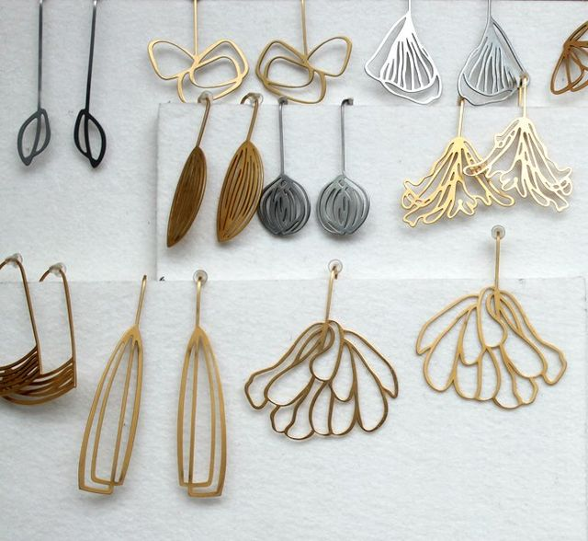

Why Choose Handmade Earrings?
Handmade earrings offer a distinctive charm that mass-produced jewelry simply can’t replicate. Here’s why they stand out:
Uniqueness – Each pair is crafted individually, ensuring no two pieces are identical.
Quality Craftsmanship – Handmade earrings are made with care, focusing on intricate details.
Sustainable & Ethical – Many handmade jewelry brands, including InSync Design, prioritize sustainability by using ethically sourced materials.
Timeless Appeal – Handmade designs often transcend trends, making them lasting investments.

Explore Our Collection of Contemporary Handmade Earrings
At InSync Design, our earrings are more than just accessories—they are wearable works of art. Our designs cater to modern, fashion-forward individuals who appreciate innovation and elegance.
Statement Earrings
Looking for a bold accessory to complete your outfit? Our statement earrings are designed to make an impact. With abstract shapes, artistic forms, and innovative materials, these pieces redefine contemporary jewelry.
Minimalist & Modern Earrings
Our minimalist earrings offer clean lines, geometric shapes, and lightweight comfort for those who prefer understated elegance. They are perfect for everyday wear while maintaining a touch of sophistication.
Handcrafted in Australia
All our earrings are proudly handmade in Australia by skilled artisans who are passionate about craftsmanship. We embrace cutting-edge techniques, combining traditional jewelry-making methods with modern design aesthetics.


How to Style Handmade Earrings
Handmade earrings in Australia can elevate any look, from casual outfits to evening ensembles. Here are some styling tips:
Bold Statement Pieces – Pair with a simple monochrome outfit to let your earrings take center stage.
Minimalist Designs – Complement sleek, modern outfits for a refined aesthetic.
Mix & Match – Combine different styles for a trendy, eclectic look.

Why Shop with InSync Design?
Award-Winning Designs – Our brand has been recognized for its contemporary jewelry aesthetics.
Sustainability-Focused – We use eco-friendly processes and responsibly sourced materials.
Exclusive Pieces – Our designs are original and crafted with attention to detail.

Shop Handmade Earrings in Australia Today
Elevate your jewelry collection with InSync Design’s handmade earrings. Whether you’re looking for a unique gift or a new addition to your personal collection, our pieces embody creativity and elegance. Shop online today and discover contemporary, handcrafted beauty.

